Student Management Portal

## **Objectives:-**

* Explain React components
* Identify the differences between components and JavaScript functions
* Identify the types of components
* Explain class component
* Explain function component
* Define component constructor
* Define render() function

**Steps:-**

**Create a New React Project**

Open the terminal in Visual Studio Code and run:

npx create-react-app StudentApp

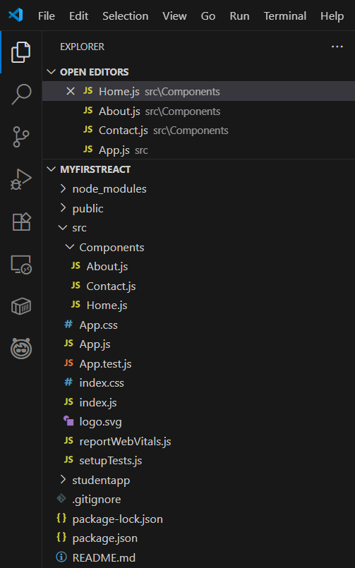

**Create Components Folder**

* Inside src/, create a folder named: Components
* Inside this folder, add a file named:

**Home.js**

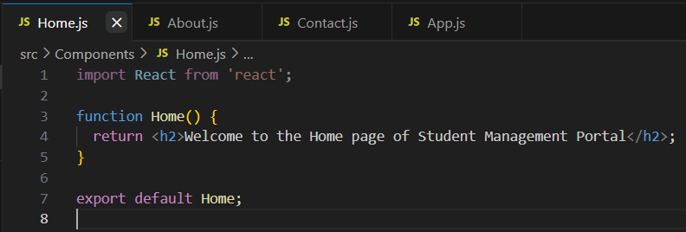

**Create About and Contact Components**

In the same Components folder:

**Create About.js**

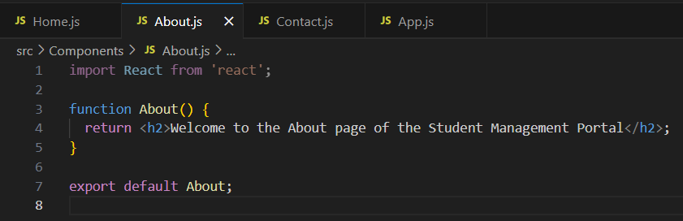

**Create Contact.js:**

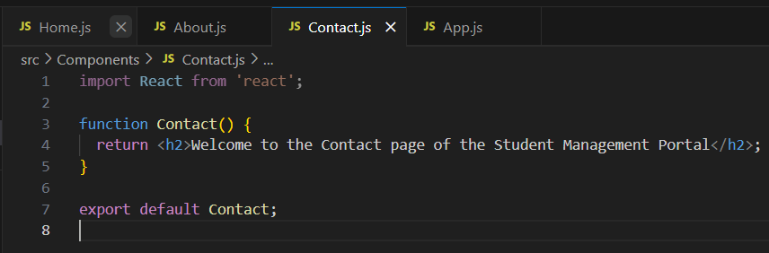

**Update App.js**

Edit src/App.js to import and render all three components:

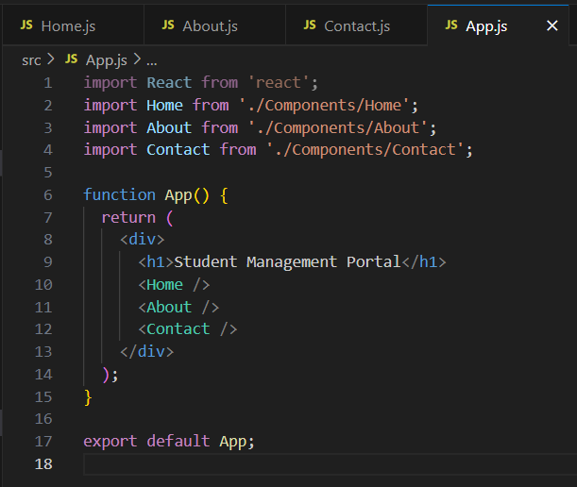

**OUTPUT:**

On performing these steps we get the desired output.

